

**PREDICTING HEALTH CONDITION USING WEARABLE DEVICE**

_______________________________________________________________________________________________________________________________

**Objective Social Relevance:**

To build up a wearable device and use sensors to get health data from It can be used to keep track of the users health condition and indicate

the user and use it in an UI to display the health condition of the user by in case of alarming deviations from the normal values which can turn

comparing the derived data with the existing data . out to be helpful in predicting a lot of health disorders.

Mentor Name::Dr.Poonkodi.M

**Block Diagram:**

**Direct connection**

**Team Members Name & Reg.No.**

1. **Tejas Kumar :23BAI1564**
2. **Avanthika.V : 23BAI1330**
3. **C.Varshah : 23BAI1371**
4. **Kadiri Neha Reddy : 23BAI1109**
5. **Leve Anto.A : 23BME1175**
6. **Saranes : 23BLC1318**

**7.Krishnaa Gopi : 23BRS1320**

**8.Joe V Kadavan : 23BLC1277**

**9.V.Purushothaman : 23BAI1556**

**10.Sree Vidhya.B : 23BME1221**

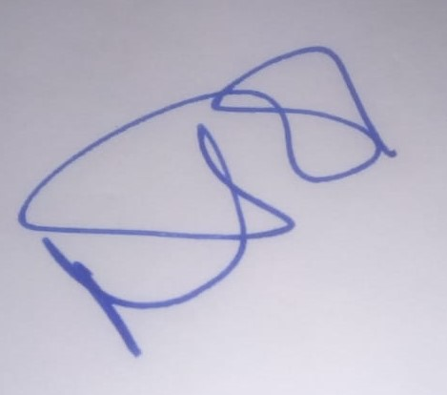

**USB Data Acquisition System**

**Computer code(using tkinter)**

**Wearabledevice**

Display the result output